**Task 2**

*Game Design Document*

1. **Target Device**:

Windows/Mac PC.

1. **Gameplay Flowcharts:**

(PDF named Flowchart)

1. **Game Mechanics:**

The player will be able to make the character move left and right and jump.

1. **Game Objectives:**

To collect the items which correspond to the game mode.

1. **Visual Assets:**

Obstacles:

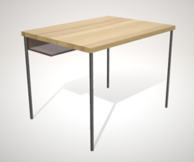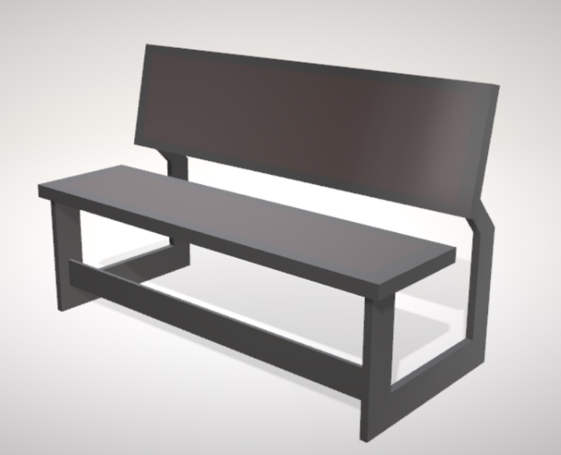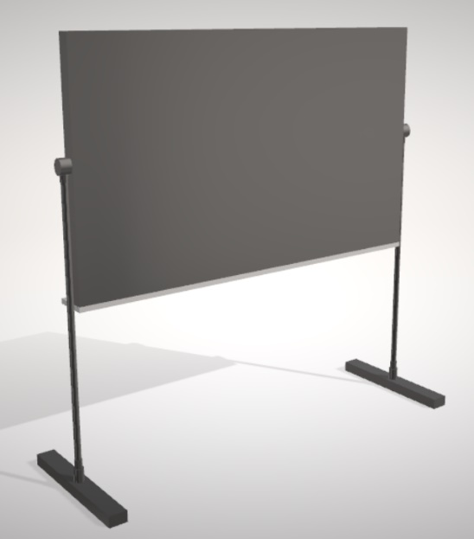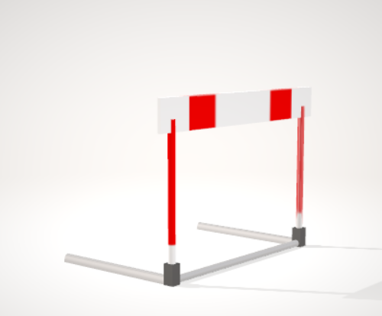

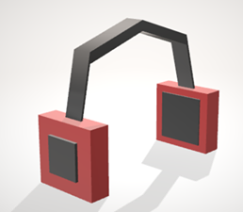Pickable Items:

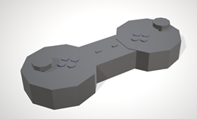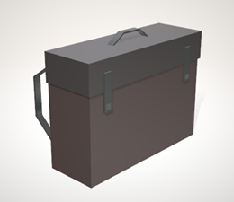

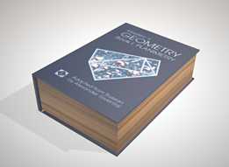

Character:

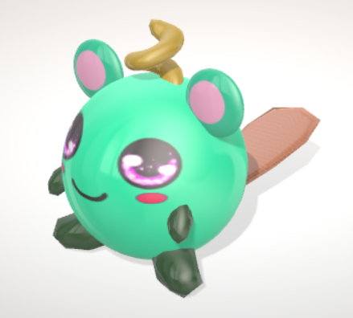

1. **UI Elements**

Points, Timer and Game mode.

1. **Game Scenes**

There will be two, one will be the starting menu and the other will be the game over screen (excluding game itself).